# Brainstorm

**TIP**

You can select a sticky note and hit the pencil [switch to sketch] icon to start drawing!

### Before you collaborate

#### A little bit of preparation goes a long way with this session. Here’s what you need to do to get going.

**10 minutes**

**1**

### Define your problem statement

#### What problem are you trying to solve? Frame your problem as a How Might We statement. This will be the focus of your brainstorm.

**5 minutes**

**2**

### Brainstorm

#### Write down any ideas that come to mind that address your problem statement.

**10 minutes**

**3**

### Group ideas

#### Take turns sharing your ideas while clustering similar or related notes as you go. Once all sticky notes have been grouped, give each cluster a sentence-like label. If a cluster is bigger than six sticky notes, try and see if you and break it up into smaller sub-groups.

**20 minutes**

**4**

### Prioritize

#### Your team should all be on the same page about what's important moving forward. Place your ideas on this grid to determine which ideas are important and which are feasible.

**20 minutes**

### After you collaborate

You can export the mural as an image or pdf to share with members of your company who might find it helpful.

**Quick add-ons**

# & idea prioritization

implementation of our project

**IoT BASED SAFETY GADGET FOR CHILD SAFETY MONITORING AND NOTIFICATION**

The overall percentage of child abusements filed nowadays in the world is about 80%, out of which 74% are girl children and the rest are boys. Due to the abusements, the emotional and mental stability of the children gets affected which in turn ruins their career and future. These innocent children are not responsible for what happens to them. So, parents are responsible for taking care of their own children. In our system, we provide an environment where this problem can be resolved in an efficient manner. It makes parents to easily monitor their children in real time just like staying beside them as well as focusing on their own career without any manual intervention.

**A Team gathering**

Define who should participate in the session and send an

**SWETHA.D**

**TIP**

Add customizable tags to sticky notes to make it easier to find, browse, organize, and categorize important ideas as themes within your mural.

**DEEPA LAKSHMI.G**

##### DURGA.B

**KEERTHI.P**

##### Share the mural

invite. Share relevant information or pre-work ahead.

child

to monitor

parents

child future

missing of

child

wearable

easy

parents

trust about

child safety

**Share a view link** to the mural with stakeholders to keep

Use this template in your own brainstorming sessions so your team can unleash their imagination and start shaping concepts even if you're not sitting in the same room.

**10 minutes** to prepare

**1 hour** to collaborate

**2-8 people** recommended

##### Set the goal

Think about the problem you'll be focusing on solving in the brainstorming session.

##### Learn how to use the facilitation tools

Use the Facilitation Superpowers to run a happy and productive session.

[**Open article**](https://support.mural.co/en/articles/2113740-facilitation-superpowers)

**Key rules of brainstorming**

To run an smooth and productive session

abusement child activity

**SAVITHA.V**

|  |  |  |
| --- | --- | --- |
| economic gadget | monitor their children in real time | without manual intervention |
|  |  |
|  |  |  |

easy monitoring

abuse

##### Person 6

|  |  |  |
| --- | --- | --- |
|  |  |  |
|  |  |
|  |  |  |

child safety

child

location tracking

##### Person 7

|  |  |  |
| --- | --- | --- |
|  |  |  |
|  |  |
|  |  |  |

gadget

notification control

satisfaction child safety responsible

**Person 8**

|  |  |  |
| --- | --- | --- |
|  |  |  |
|  |  |
|  |  |  |

child location tracking

child safety

without manual intervention

parents satisfaction

wearable gadget

testing our project model and parents satisfaciton

them in the loop about the outcomes of the session.

**B Export the mural**

Export a copy of the mural as a PNG or PDF to attach to emails, include in slides, or save in your drive.

**Keep moving forward**

##### Strategy blueprint

Define the components of a new idea or strategy.

##### [Open the template](https://app.mural.co/template/e95f612a-f72a-4772-bc48-545aaa04e0c9/984865a6-0a96-4472-a48d-47639307b3ca)

**Customer experience journey map**

Stay in topic. Defer judgment.

Encourage wild ideas. Listen to others.

**Importance**

If each of these tasks could get

## make a idea

Then make a discussion over our team members about solution

Understand customer needs, motivations, and obstacles for an experience.

[**Open the template**](https://app.mural.co/template/b7114010-3a67-4d63-a51d-6f2cedc9633f/c1b465ab-57af-4624-8faf-ebb312edc0eb)

Go for volume. If possible, be visual.

done without any difficulty or cost, which would have the most positive impact?

## on IoT based

gadget to

## monitoring

child safety

##### Strengths, weaknesses, opportunities & threats

Identify strengths, weaknesses, opportunities, and threats (SWOT) to develop a plan.

|  |  |
| --- | --- |
|  |  |
|  |  |

##### [Open the template](https://app.mural.co/template/6a062671-89ee-4b76-9409-2603d8b098be/ca270343-1d54-4952-9d8c-fbc303ffd0f2)

first recognize our problem statement

###### TIP

Participants can use their cursors to point at where sticky notes should go on the grid. The facilitator can confirm the spot by using the laser pointer holding the **H key** on the keyboard.

##### [Share template feedback](https://muralco.typeform.com/to/CiqaHVat?typeform-source=app.mural.co)

[**Share template feedback**](https://muralco.typeform.com/to/CiqaHVat?typeform-source=app.mural.co)

**Feasibility**

Regardless of their importance, which tasks are more feasible than others? (Cost, time, effort, complexity, etc.)

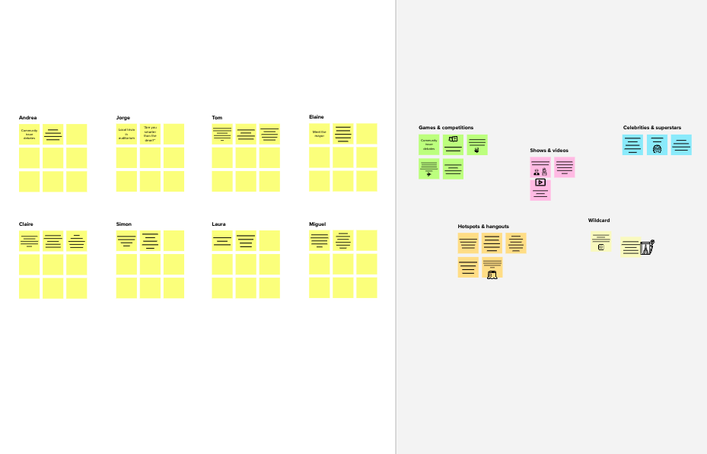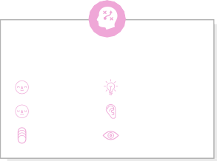

**Template**

**Need some inspiration?**

See a finished version of this template to kickstart your work.

###### [Open example](https://app.mural.co/template/e5a93b7b-49f2-48c9-afd7-a635d860eba6/93f1b98d-b2d2-4695-8e85-7e9c0d2fd9b9)